This tool is published by INTRAC in conjunction with the Partner Capacity Strengthening toolkit for small charities authored by Catherine Squire – part of a collection of five toolkits produced as part of the Strengthening Small Organisations with Big Ambitions programme (2021-2022). This programme was funded by the UK Foreign, Commonwealth & Development Office (FCDO) through a Small Charities Challenge Fund (SCCF) Capacity Development Grant.

PCS3.3 - Life cycle activity

This activity guide is released with the Partner Capacity Strengthening Toolkit for Small Organisations with Big Ambitions. Please refer to the toolkit for further guidance on when and how to use this activity. We recommend you read the whole toolkit at least once before using any of the tools.
In this guide we’ll present options to facilitate this activity both face-to-face and as part as an online meeting.

OPTION 1 – FACE-TO-FACE MEETING

Set up:
- If possible, draw a large version of the life cycle (see image below) with chalk, string or ribbon on the floor.
- Print annex 1 of this toolkit (pages 5-11) on A4 paper, or copy the description of each stage onto large cards.
- On the back of each paper, write the name of the stage in large print.

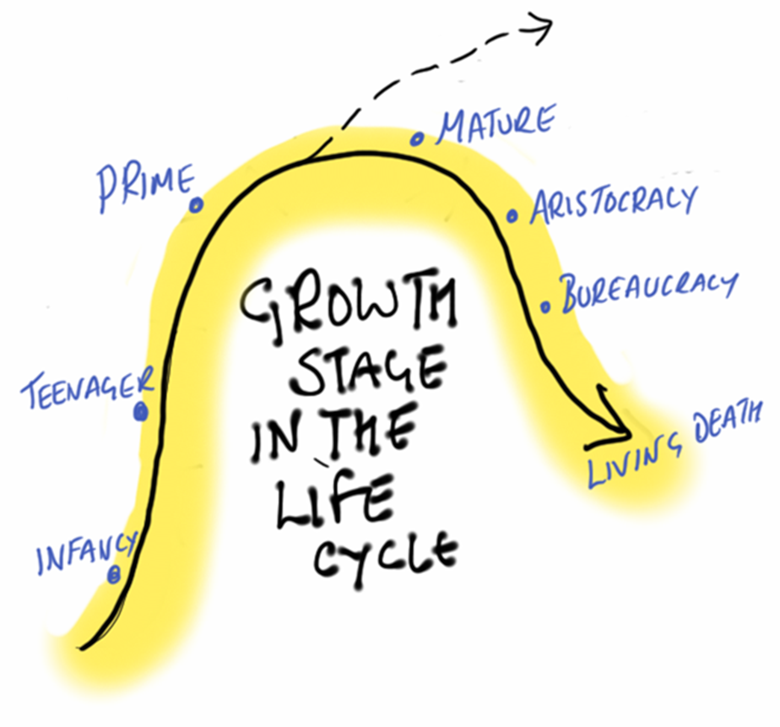

- Infancy: a good idea, just needs a bit of help
- Teenager: dynamic and experimental, unstructured, founder-led and takes lots of risks
- Prime: transitioned to a more distributed leadership, with systems set up, innovating and effective
- Mature: still very effective, starting to be less innovative
- Aristocracy: belief in self is stronger than desire to change and evolve with new challenges
- Bureaucracy: forgetting what the organisation is there to do, focus on procedure rather than results
- Living death: the organisation has become irrelevant and continues only because no-one can be bothered to close it down!

Steps:
- Invite participants to think of an organisation they know (not their own) and move to the place on the curve that they associate with that organisation.
- Share in their groups what organisation they chose and why. Look at the back of the card and discuss what they think the organisations need to do.
- Now invite them to think of their own organisation, and move to the place on the curve they think represents their organisation. Not everyone needs to be on the same place!
- Encourage people to share why they chose a particular stage. Encourage debate between different ideas – there is no ‘right’ answer.
- Discuss what the implications might be for the organisation’s development.

OPTION 2: ONLINE MEETING
While face-to-face meetings are normally preferrable, there are plenty of reasons why they may not always be possible – one is of course a pandemic, but increasingly also considerations related to international travel (including environmental and economic costs of flying), unequal access to visas (from and to certain countries), caring responsibilities, security issues, and so on.
To run this activity virtually as part of a conference call, we have created a template on Mural, but you could use another digital whiteboard tool (Mural, Miro, Jamboard, etc). Remember that all these digital whiteboards have limitations, in particular they aren’t accessible to visually impaired users.

Initial set-up (before the session):
Here’s a Mural template that you can adapt (see also Mural tips on page 4)

This template has been created with Mural, a digital whiteboard tool. You will need a Mural account – even just a free one – to be able to access the template and create your own copy (note that free users may experience some limitations).
Remember that digital whiteboards like Mural aren’t fully accessible to visually impaired users.

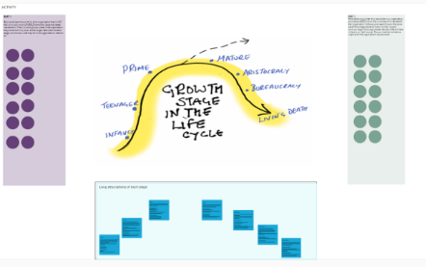
- Set up the life cycle diagram either using the template above, or re-creating it on a different platform. Your whiteboard should look more or less like the screenshot below:

Activity facilitation during the meeting
- Invite participants to think of an organisation they know (not their own) and have them move one PURPLE dot (or sticky note) to the place on the curve that they associate with that organisation.
- In small groups, have them share what organisation they chose and why. Look at the “long descriptions” and discuss what they think the organisations need to do.
- Now, invite participants to think of their own organisation, and move a GREEN dot to the place on the curve they think represents their organisation. Not everyone needs to be on the same place!
- Encourage people to open their microphone and share why they chose a particular stage. Then, encourage debate between different ideas – there is no ‘right’ answer.
- Let the group discuss what the implications might be for the organisation’s development.

Annex 1 – for printing
Mural tips:
- When sharing a Mural with participants, always send the “visitor” link rather than the “member/guest”, as the latter will force each user to create an account.
- Make sure that the person who is facilitating the session is logged in either as the Mural owner, or has been given “facilitation superpowers”, so they will be able to:
  - “Summon” other users to have them move to a specific part of the Mural
  - Lock and unlock items on the whiteboard
- Familiarise with Mural before the meeting! It becomes easier with practice.
- Refer to Mural’s own help pages for detailed support on how to use different features.

Infancy
The organisation has been born! Only very basic policies/systems are developed at this stage.

The NGO lacks experience (no track record).
It is opportunity driven.
Very vulnerable to changes in the external environment.

Potential danger: ‘Infant Mortality’

Possible solutions:
- Funding.
- Inexpensive support from other NGOs

INSTRUCTIONS: Print this page, turn it over, and write “INFANCY” in large print on the back
Teenager:
Very agile, energetic, takes risks, jumps at new opportunities but little experience of prioritising.
Everybody knows what everybody else is doing - good communication and participation.
Each person shares responsibilities with the others - very participatory.

Potential dangers:
- Founder’s Trap: too dependent on founder.
- Danger of diversifying too soon and becoming over-stretched.
- May start unrealistic ventures which the organisation is not able to implement.

Possible solutions:
- Founder sharing responsibility with other members.
- Learning to prioritise.
- Setting up systems and governance structures.

INSTRUCTIONS: Print this page, turn it over, and write “TEENAGER” in large print on the back
Prime:
Strong ‘results orientation’.
A balance of self-control, flexibility and responsibility has been reached.
Institutionalised vision and creativity in all its work.
Strategic approach is strong: knows what it is doing, where it is going and how to get there.

Potential dangers:

- Internal Conflict
- Reduced commitment
- Interest declines
- Some doubt may arise about whether the organisation’s priorities are right.

Possible solutions:
- Decentralise decision-making.
- Diversify activities if necessary.
- Focus on human development.

INSTRUCTIONS: Print this page, turn it over, and write “PRIME” in large print on the back
Mature:
Still strong but losing flexibility and creativity.
Provides fewer incentives to visionary thinking.
New ideas are received without enthusiasm.
Lower expectations for growth.
Starts focusing on past achievement instead of future visions
End of growth period and start of decline (watch for signs to take corrective measures).

Potential dangers:
- Inward focus may develop
- Lack of Vision and ability to change and evolve with new challenges.

Possible solutions:
- Renewal of Vision
- Revision of mission and strategy in the light of changing external context and issues.

INSTRUCTIONS: Print this page, turn it over, and write “MATURE” in large print on the back

Aristocracy:
Greater proportion of budget spent on administrative control systems.
Emphasis on how things are done rather than what and why things are done.
Formality at the expense of functionality.

Potential dangers:
- Stagnation and low internal innovation
- Decline of performance.

Possible solutions:
- External consultant needed to shake-up.
- Reconnection with Values and relevance of Mission.
- Stakeholder input into new approaches.

INSTRUCTIONS: Print this page, turn it over, and write “INFANCY” in large print on the back
Bureaucracy:
Nothing of any importance gets done.
Dissociates itself from its environment and focuses mostly on itself. Makes it difficult for outsiders (especially stakeholders) to gain access.
Only remaining systems are administrative rules and regulations

Potential dangers:
- Lack of activity and results.
- Red Tape. Lack of credibility with stakeholders.

Possible solutions:
- By this time death may be the best solution.

INSTRUCTIONS: Print this page, turn it over, and write “BUREAUCRACY” in large print on the back

Living death:
Organisation expires (either quietly in its sleep or painfully if the members are not prepared to move on).

Potential dangers:
- May not accept that death is near.
- The earlier lessons from the organisation may be lost.

Possible solution:
- Someone to provide a fitting funeral and mourn the organisation’s demise.

INSTRUCTIONS: Print this page, turn it over, and write “LIVING DEATH” in large print on the back

