This tool is published by INTRAC in conjunction with the Strategic Planning toolkit for small charities authored by Rick James – part of a collection of five toolkits produced as part of the Strengthening Small Organisations with Big Ambitions programme (2021-2022). This programme was funded by the UK Foreign, Commonwealth & Development Office (FCDO) through a Small Charities Challenge Fund (SCCF) Capacity Development Grant.

Strategic planning tools - Prioritisation activity guide
In strategic planning the following prioritisation exercise can be helpful in bringing to light implicit priorities. Please refer to section 6 of the Strategic Planning toolkit for guidance on how and when to use this tool. NB We strongly recommend you read the whole toolkit at least once before starting to use any of the tools.
In the following pages, you will find some step-by-step guides to facilitate a prioritisation exercise in a face-to-face meeting, as well as a few options to adapt it for online workshops.
Face-to-face workshop
Initial set up:
- Write the names of all your programmes / projects on a flipchart or whiteboard.
- Get people to write these out on separate pieces of paper.
- Put out three buckets/boxes (or just identify three piles) on a table. Label them A, B, and C.

Activity:
STEP 1, ask the question, “If revenue were to drop by 50%, which programmes would we stop doing first?” Have each person put these in the bucket/box/ area C.
STEP 2, ask: “If revenue dropped by 75% and we had to move onto the next round, what would we stop doing?” These will go in the bucket/box/area B.
STEP 3, ask:, “What would we never stop doing?” Have each person put their response in the bucket/box/area A.

Debrief and discussion:
When everyone has finished, look at what’s in each bucket/box/area and discuss the results:
• What is it clear that you should stop doing?
• What is it clear you should never stop doing?
Online workshop
While face-to-face meetings are normally preferrable, there are plenty of reasons why they may not always be possible – one is of course a pandemic, but increasingly also considerations related to international travel (including environmental and economic costs of flying), inequal access to visas (from and to certain countries), caring responsibilities, security issues, and so on. In the following pages, we propose three different options to re-create the suggested prioritisation activity virtually, which you should adapt to suit your own organisation’s needs.
Note: Some of the templates linked in the following pages have been created with Mural, a digital whiteboard tool. You will need a Mural account – even just a free one – to be able to access the templates and create your own copy (note that free users may experience some limitations). In this guide, we describe the set up with as much details as possible, so that you can recreate the same set up on a different platform.
Mural tips:
- When sharing a Mural with participants, always send the “visitor” link rather than the “member/guest”, as the latter will force each user to create an account.
- Make sure that the person who is facilitating the session is logged in either as the Mural owner, or has been given “facilitation superpowers”, so they will be able to:
  - “Summon” other users to have them move to a specific part of the Mural
  - Launch a voting session
  - Lock and unlock items on the whiteboard
  - Enable “private mode”, where people don’t see other user’s activity
- Refer to Mural’s own help pages for detailed support on how to use different features.

Online option A – Digital whiteboard
This set up can be created on Mural or on another digital whiteboard of your choice (remember these aren’t accessible to visually impaired users). This option is set up in a way that most closely resemble the one described for face-to-face meetings. However, it may be impractical if there are more than a handful participants and/or a large number of programmes.
Here’s a Mural template that you can adapt (see also Mural above): https://app.mural.co/template/d74555c1-3973-40b5-ae2d-d3af27f49a45/fc48aca2-0c0b-4ed8-98ac-75cb85e9ff1f

Initial set up (before the session):
- Write the names of all your programmes / projects on virtual “sticky notes”. If you feel creative, you may want to include pictures, icons or logos.
- Duplicate the area with the sticky notes so that each participant has a “full stack” covering all of the projects, and label the area with the participant’s name to avoid confusion.
- At the centre of the virtual board, create 3 areas and label A, B and C. Below is a screenshot to give you an idea:
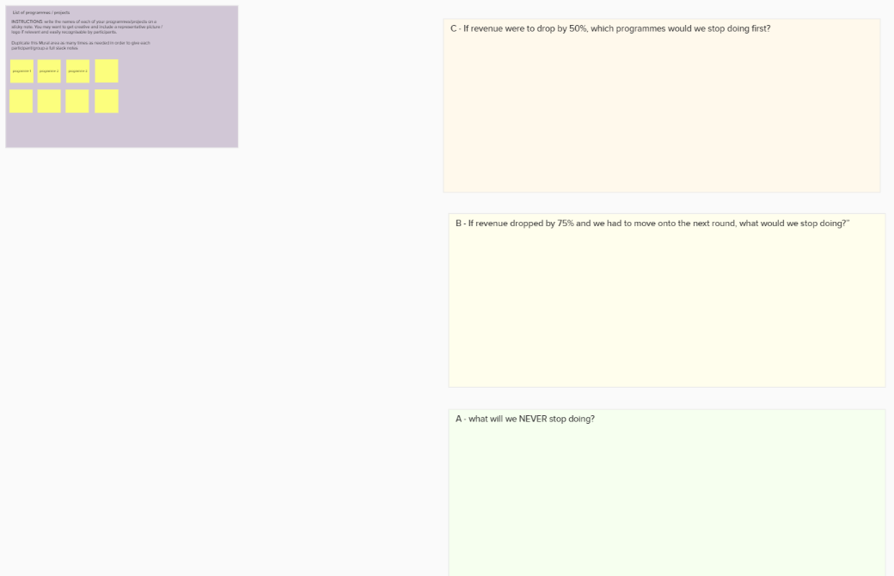
Activity
(you may want to enable “private mode” so that participants’ are less likely to be influenced by other people’s choices)
- STEP 1, ask the question, “If revenue were to drop by 50%, which programmes would we stop doing first?” Have each person put move the sticky notes to area C.
- STEP 2, ask: “If revenue dropped by 75% and we had to move onto the next round, what would we stop doing?” These will go into area B.
- STEP 3, ask:, “What would we never stop doing?” Have each person move the sticky notes into area A.

Debrief and discussion:
When everyone has finished, look at what’s in each area, and discuss the results:
• What is it clear that you should stop doing?
• What is it clear you should never stop doing?

Online option B – in-conference polling

This set up can work well with somewhat larger groups of people, and a relatively small number of programmes/projects (10 or less).
An advantage is that it works in the same video communication app that you are using for the virtual meeting (e.g. Zoom or similar), instead of having participants open another tool.
However, there is a chance that people might get confused and include the same programme in more than one list (less likely if there just a handful of projects, and if you make sure that they take notes beforehand).
Initial set up (before the session):
- Ahead of the meeting, share the list of programmes / projects for people to print out as in the table below; Alternatively, everyone should bring pen and paper to take notes.
Project / programme title | Priority code (A,B, C)
- ABC Programme
- DEF Programme
- GHI Programme
- JKL Programme
- Prepare a slide with the list of all your projects / programmes. Use the same order and numbers as in the list you shared before the meeting.
- Using the in-meeting polling system, set up a multiple choice poll with 3 questions, remembering to allow for multiple selection:
  - Tick all the projects you marked with “C”: drop if revenue falls by 50%
  - Tick all the projects you marked with “B”: drop if revenue falls by 75%
  - Tick all the projects you marked with “A”: never stop doing
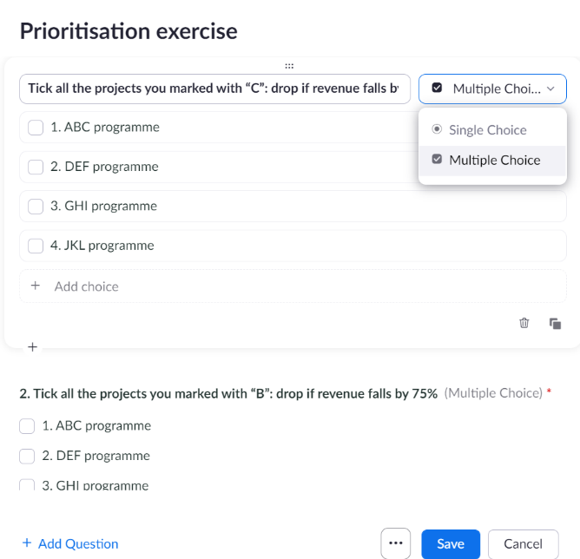
For each of the questions, the options for the answers should be each of the programmes / projects in your list (including numbers, if used). Note that Zoom currently allows up to 10 options.

Activity:
Show the slide with the list of programmes/projects, then ask the first question: “If revenue were to drop by 50%, which programmes would we stop doing first?” Invite participants to label these with a letter C in their own copies of the table. They should NOT share their selection at this stage.
- Then ask: “If revenue dropped by 75% and we had to move onto the next round, what would we stop doing?” These should be labelled with B.
- Last question: “What would we never stop doing?” These are the As.
- Remind participants that at this point, each programme / project in their list should have one letter (and only one) next to it.
- Finally, launch the poll you prepared and invite participants to select options based on their own table / notes taken during the activity.

Debrief and discussion:
When everyone has finished, share the poll results and discuss:
• What is it clear that you should stop doing?
• What is it clear you should never stop doing?

Option C – using a digital whiteboard
This set up can be created on Mural or on another digital whiteboard of your choice (remember these aren’t accessible to visually impaired users). You need to ensure that each user only sees their own activity, and not other what others are doing, until debrief time (this feature is called “private mode” on Mural). This is both to prevent participants from being influenced by other people’s selections, and to let each person remember what they selected on previous rounds.
Here’s a Mural template you can use to develop your own whiteboard: (see also Mural tips on page 2): https://app.mural.co/template/d8ca643c-d0e4-409f-8148-6ac807d3bbb9/2fbf7ef2-8d67-4430-b12b-713502cbb8d4

Initial set up (before the session):
- Write the names of all your programmes / projects on virtual “sticky notes” on your whiteboard. If you feel creative, you may want to include pictures, icons or logos to visualise each programme.
- Create three smaller areas, and fill each with green, amber and red “dots” respectively. Make sure there are enough “dots” of each colour per person (to be on the safe side, use the formula “number of programmes” x “number of participants” per each colour).
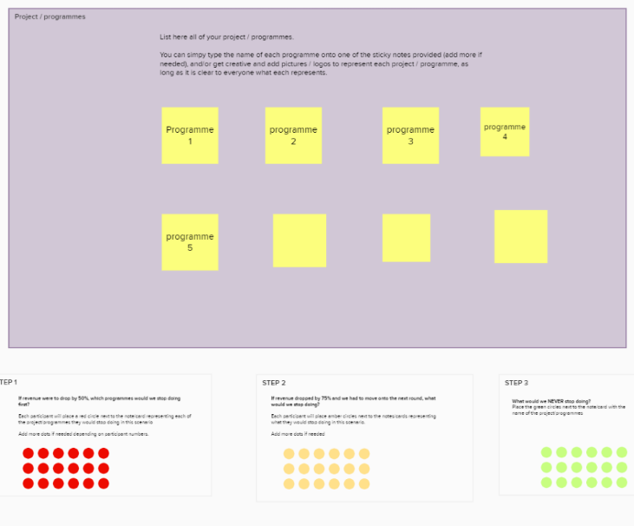
- Enable “private mode” so that participants won’t be able to see other people’s preferences until debrief, and will also view where they have already placed a dot so they don’t give assign two conflicting priorities to the same programme/project.
Activity
STEP 1, ask the question, “If revenue were to drop by 50%, which programmes would we stop doing first?” Have each person drop a RED dot (or equivalent) next to the project title.
STEP 2, ask: “If revenue dropped by 75% and we had to move onto the next round, what would we stop doing?” Invite people to put AMBER dots next to those.
STEP 3, ask:, “What would we never stop doing?” Participants should use GREEN dots for these projects.
Remind everyone that each project should have ONE and ONLY ONE dot next to it, and allow time to make corrections before debrief.

Debrief and discussion:
When everyone has finished, end private mode to reveal everyone’s preferences, and discuss the results:
• What is it clear that you should stop doing?
• What is it clear you should never stop doing?

